**Instructions:**

* Fill your Name and REGNO.
* Complete all the programs, add the code java and XML, input and output Screenshots after the question on the same document.
* Save this File name with your **registerno**_**lab2**

**eg 18ABC1234_LAB2.doc**

* Upload it in assignment ->LAB2 in MS TEAM

Lab2:

1. Design the following APP for the IOT store. The cost of Aurdino Uno is 500RS, the cost of WIFI module is 250RS and the Bluetooth module is 200RS. Based on the quantity compute the Amount payable when submit button is clicked, When clear is clicked clear all the Editboxes.

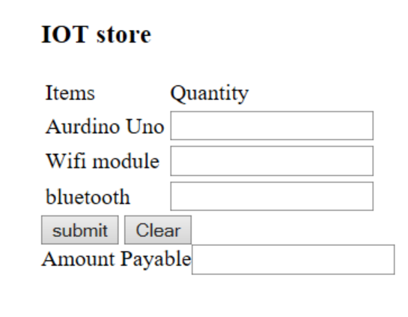

1. Design a Currency converter App. 